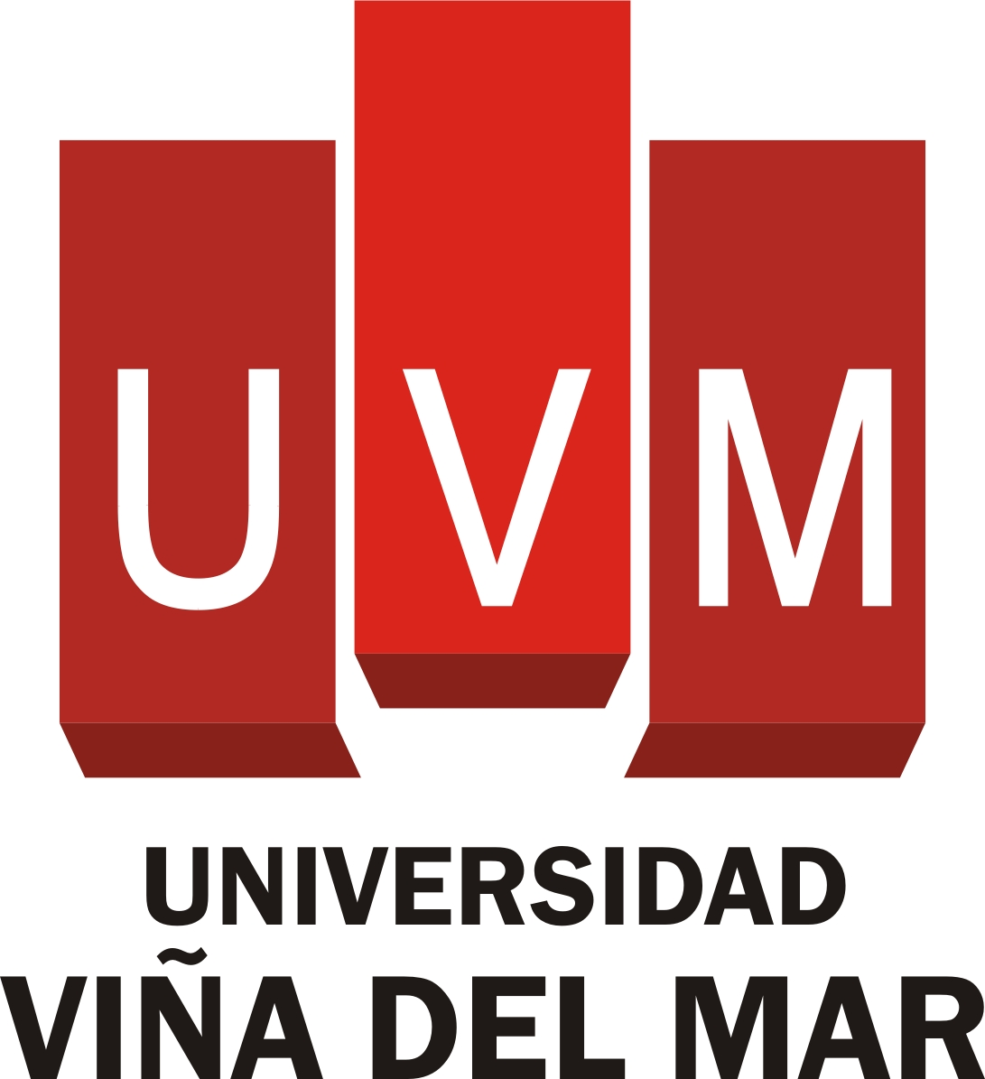
(Other Institute’s Logo)

STUDENT EXCHANGE AGREEMENT
Between
UNIVERSIDAD VIÑA DEL MAR, CHILE
And
XXXX

The University Viña del Mar (hereinafter referred to as UVM) and XXXX (hereinafter referred to as XXX) agree to the following terms.

Definitions

In this Agreement, unless the context will otherwise imply:

HOME institution means the institution at which the student intends to graduate; HOST institution means the institution that has agreed to receive students from the HOME institution.

ACADEMIC YEAR in the context of UVM refers to two semesters, from Mid-August to Mid-December (Semester 2) and March to June (Semester 1); and in the context of XXX means XXX.

EXCHANGE STUDENTS means students attending the HOST institution with no requirement to pay tuition fees to that institution and where reciprocal obligations exist for the HOME institution to accept for enrollment students from the HOST institution in exchange, subject to the conditions outlined in this Agreement.

STUDENT EXCHANGE

Purpose

The objective of this agreement is to establish specific relations and cooperation between these two institutions in order to enrich the understanding of the culture of the two countries concerned. This Agreement is to make possible on a continuing basis the exchange of undergraduate and graduate students.

The purpose of each student exchange will be to enable undergraduate and graduate students to take units (classes) but not to study for a degree at the HOST institution.

Units passed at the HOST institution will normally be accepted for credit towards the degree at the candidate’s HOME institution for which he or she is enrolled. It will be the responsibility of each student in the student exchange to obtain official approval from his or her own institution for units taken at the HOST institution.
Exchange Numbers

Subject to the availability of suitable candidates, up to two (2) undergraduate students each academic year may be exchanged for the purpose of study at the HOST institution during the term of this Agreement, beginning with the 20XX academic year, unless varied by mutual agreement. In principle, the exchange of students will occur on a one-for-one basis. The number of exchange for each institution may vary in any given year, but over a fixed period of five years, the total number of students participating shall be balanced. The normal exchange period for UVM students going to XXX shall be for a semester or academic year. The normal exchange period for XX students going to UVM shall be for one semester.

Selection of Students

The HOME institution will screen applications from its student body for exchange or study abroad. The program is available to undergraduate students who have completed at least one academic year of the basic degree programs, and to graduate students having equally completed the first year of graduate studies.

Each institution will send the other completed applications for their students as follows:

UVM will forward to XXX by the 1st of October and the 1st of May a list of the students nominated for exchange in the following Semester, together with appropriate documents as required.

XXX will forward to UVM by the 1st of June and the 1st of December a list of the students nominated for exchange or study abroad in the following semester, together with appropriate documents as required.
Students may apply to any academic program offered at the respective HOST institution, however, the HOST institution reserves the right to make final judgement on the admissibility of each student nominated. The HOST institution also retains the right to assess a student’s language proficiency (if applicable) or previous academic background before admitting that student to any course. This may limit the range of courses at the HOST institution open to the exchange or study abroad student. All exchange and study abroad students shall agree to abide by the rules and regulations of the HOST institution.

It is expected that the HOST institution will not reject a nominated student unless he/she does not meet established admission requirements for international students, or unless the HOST institution cannot guarantee availability of requested courses.

Responsibilities of the two institutions

UVM and XXX agree to accept exchange students from each other and enroll them as full-time ‘not for degree’ students for the regular semesters or quarters of the academic year. Each institution will provide the necessary counseling and other assistance to the exchange students.

The HOME institution shall satisfy itself that the nominated student has met the financial conditions stipulated before granting acceptance.
All students will remain enrolled as regular degree candidates at the HOME institution and will not be enrolled as candidates for degrees at the HOST institution.

Students are required to maintain full-time status at the HOST institution.

The HOST institution shall render all assistance to the student in locating accommodation within a reasonable distance of the campus.
Each XXX student studying at UVM will be provided, without further payment with:
Teaching, Counseling, Orientation, Reports and statement of results

Each UVM student studying at XXX will be provided, without further payment with:
Teaching, Counseling, Orientation, Reports and statements of results

Financial responsibility of participating students

Each student participating in the exchange program shall meet the full costs related to:

Travel to and from the HOST country, including appropriate travel insurance
Books and stationery
Travel documents and visas
Living and subsistence expenses
Application or related fees for participating in the program as may be charged by the HOME institution

The cost of health insurance at the HOST institution and HOST country

Student Dismissal

Each institution reserves the right to dismiss any participating student at any time for academic or personal misconduct in violation of institutional regulations. The dismissal of a student shall not abrogate the Agreement or the arrangements regarding other students in the exchange.

Extensions

Upon completion of the student exchange at the HOST institution, the participating students must return to the HOME institution. No extension of stay shall be authorized unless otherwise specified by the HOME institution.

Terms of Agreement and Amendment

This Agreement shall remain in force for a period of five (5) years from the date of signing with the understanding that it may be revised, terminated, or suspended pending availability of places by either party giving six months written notice to the other party.

This agreement is signed in two equal copies.

SIGNATURES

This Agreement constitutes the entire Agreement between the parties. There are no understandings, agreements, or representations, oral or written, not specified herein regarding this Agreement. No amendments, consent, or waiver of terms of this Agreement shall bind either party unless in writing and signed by all parties. Any such amendment, consent, or waiver shall be effective only in the specific instance and for the specific purpose given. UVM and XXX by the signatures of their authorized representatives below acknowledge having read and understood the Agreement and agree to be bound by its terms and conditions.

Signed for and on behalf of Signed for and on behalf of XXXX
Universidad Viña del Mar
CHILE

Rector Rector

_____________________________ ___________________________
Sr. Julio Castro Sepúlveda

Date: ________________________ Date: ______________________

Vicerrector Académico

_____________________________
Sr. Juan Pablo Prieto Cox

Date: ________________________

Stamp: Stamp:

