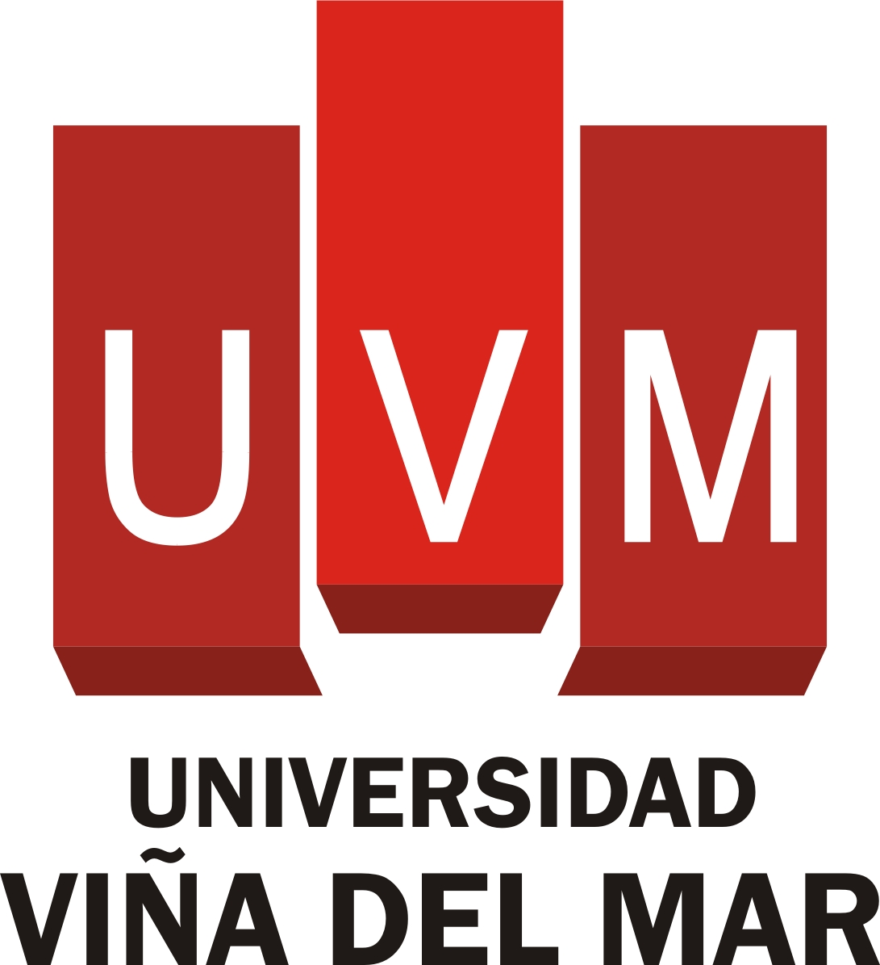 *(logo of signatory university)*

COOPERATION AGREEMENT BETWEEN

THE UNIVERSIDAD VIÑA DEL MAR AND XXX

**PRESENT**

On the part of Dr. Juan Pablo Prieto Cox, Rector of the Universidad Viña del Mar (hereafter UVM), with the address of Agua Santa 7055, Sector Rodelillo, Viña del Mar, and on the part of Mr./Mrs. XXXX, Rector of the XXX (hereafter XXX), with the address of XXXX,XXXX.

Both parts recognize their mutual legal capacity to take part in this act.

**ANTECEDENTS**

That, as institutions committed to higher education, research, and the promotion of culture, the UVM and XXX wish to encourage educational programs and mobility programs for lecturers and students between our respective institutions by means of exchange programs, and to further our mutual interests by cooperating on an equal and mutually collaborative basis.

To this end, we formalize this agreement in accordance with the following:

**CLAUSES**

**One. Objectives of the Collaboration**

This agreement has the following objectives:

1. To establish the general conditions for scientific, technical teaching, and administrative collaboration between both universities.
2. To promote the execution of joint projects in research, training, and management, in accordance with our common interests and the funds available.
3. To encourage the creation, organization, and coordination of academic activities.
4. To facilitate the exchange of members of the university community in accordance with the internal regulations of each university.

# Two. Forms of Collaboration

The collaboration between both universities is aimed at exchanges of teaching staff, research staff, students, and administrative and support staff. The UVM and XXX agree, in accordance with the funds that each has available, to carry out all or some of the following proposals:

1. To accept students and teaching, research, administrative, and technical support staff from the other university.
2. To collaborate in scientific and/or technical programs of interest to both parties.
3. To exchange scientific and technical documentation and information.
4. To establish the manner in which both institutions provide student assistance through the allocation of study and research grants.

**Three. Organization of the Collaboration**

1. Each university must appoint a coordinator who will supervise and coordinate the activities carried out under the aegis of this agreement.
2. Both parties must mutually consult each other whenever both deem it to be necessary.
3. At regular intervals a report must be presented describing the projects that have been or are being carried out, as well as the plans for future projects.
4. The programs, duration, and forms of collaboration and the expansion of their remit will be established by means of specific agreements that must be added to this framework agreement.

**Four. Duration**

1. The present agreement will come into force as soon as it has been signed and will have a duration of XXX years, and will be extended automatically for periods of XXX.
2. Either party can terminate the agreement by giving the other party six months written notice. In all cases, all the tasks and commitments agreed on in the specific agreements and which are in progress at the time of termination or modification of the present agreement must be completed.

**Five. Resolution of Disputes**

The signatories must resolve any doubt or issue regarding this agreement by consensual negotiation and common agreement. Should they be unable to reach a common agreement, the signatories will resolve their differences regarding the interpretation or fulfillment of this agreement by another means that they will determine by common agreement.

**Six. Data Protection**

Data confidentiality and the handling of information are covered by the legislation on personal data protection. Both parties agree to respect the legislation on personal data protection for all matters where this legislation is applicable to the information that is the object of this agreement.

As proof of conformity, the representatives of the UVM and of XXX sign this document in duplicate, one in Spanish and the other in English.

Viña del Mar, __ MONTH 20__

**On the part of the Universidad Viña del Mar**

**____________________________________**

**Dr. Juan Pablo Prieto Cox Sr. XXXX**

**Rector**

**On the part of XXXXXXXX**

**_____________________________________**

**Sr./a XXXXXXXX**

**Rector/a**